FA Rework Vendor Inbound

Technical Design Document

**AXAPAC**

**Power Platform Development**

**Versioning Management**

|  |  |  |  |
| --- | --- | --- | --- |
| **Date** | **Author** | **Version** | **Comments** |
| 12-03-2024 | Almas Gajendragad | 1.0 | Draft |
|  |  |  |  |
|  |  |  |  |
|  |  |  |  |
|  |  |  |  |

**Validation Management**

| **Date** | **Name** | **Version** | **Approval** |
| --- | --- | --- | --- |
|  |  |  |  |
|  |  |  |  |
|  |  |  |  |
|  |  |  |  |

Contents

**1.** **Development Info** 4

**2.** **Business Requirements** 4

**3.** **Assumptions** 4

**4.** **Dependencies** 4

**5.** **Existing Behavior** 4

**6.** **Desired Behavior** 5

**1.** **Flow Chart/ Algorithm** 5

**2.** **Interface Field Mapping & Rules** 5

**3.** **Report Design and Field Mapping** 5

**4.** **Solution Details** 5

**List of connectors Required for Power Platform Solution:** 5

**7.** **Labels -NA** 13

**8.** **Roles and Security- NA** 13

**9.** **Test Results** 13

Test Cases: 15

**II.** **CR#1 [Jira ID] [Description]-NA** 17

**1.** **Business Requirements** 17

**2.** **Assumptions** 17

**3.** **Dependencies** 17

**4.** **Existing Behavior** 17

**5.** **Desired Behavior** 17

**1.** **Flow Chart/ Algorithm** 17

**2.** **Interface Field Mapping & Rules** 17

**3.** **Report Design and Field Mapping** 17

**4.** **Solution Details** 17

**6.** **Object List** 18

**7.** **Labels** 18

**8.** **Roles and Security** 18

**9.** **Test Results** 18

# **Development Info**

|  |  |
| --- | --- |
| **Service Account** | SA-APACFARework |
| **Power platform Environment** | L_P_APAC_POCFARework_DEV |
| **On Premises Data Gateway** | SA-APACFARework_DW |
| **Shared Folder Path for ORLI file -Source** | \\HKDATAPAXU02\AX_Interface\UAT\CHK\APOLLO\IN\IN |
| **OneDrive File Path - Destination** | OneDrive\FA Rework Inbound Vendor Invoice for POC |
| **AX Server Name** | HKDATAPAXU02 |
| **Stored Procedure Name** | CNLAS_GetVendInvShipmentStatus |

# **Business Requirements**

* The invoice details in ORLI file (*csv file) from AX shared path, should be shown in Power App

interface.

* **Shipment status, Invoice Status and Pending invoice status** should be visible to user in the app.
* The invoice details should be sent as pdf invoice via mail to finance team.
* The invoice details should also be sent as excel file via mail to finance team.

# **Assumptions**

* The ORLI file will be picked from AX shared folder and would be stored in OneDrive using File System connector in Power Automate.
* From OneDrive ORLI file data will be then structured into tables and stored into Dataverse using Power Automate.
* A stored procedure in SQL server will be executing from Power Automate. And **Shipment status, Invoice Status and Pending invoice status,** Will be stored into Dataverse.
* Executing Stored Procedure from Power Automate will be every 4 hours.

# **Dependencies**

* AX dependency to save ORLI file into AX shared folder path.
* AX dependency to have SQL stored procedure query.

# **Existing Behavior**

Presently in AX there are many other fields in “Inbound vendor Invoice” Form which user do not need those fields, also the Form consists of lot of data which is making AX system run slower.

# **Desired Behavior**

## **Flow Chart/ Algorithm**

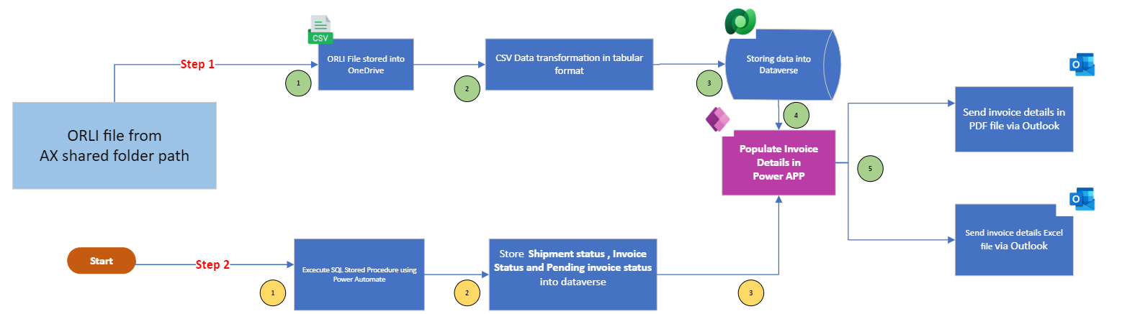

fig:1.0 Power Platform Desired Solution

## **Interface Field Mapping & Rules**

N/A

## **Report Design and Field Mapping**

N/A

## **Solution Details**

After identifying performance issue in AX, RPA team proposed a solution which involves developing Power Apps application that will handle certain processes. By offloading some tasks to Power Apps, can reduce the strain on AX.

**List of Power Automate connectors Required for Power Platform Solution:**

1. File System Connector
2. One Drive
3. Dataverse
4. SQL Server
5. Excel
6. SharePoint
7. Outlook
8. Word Online (Business)
9. Office365 User Group
10. Office365

In fig.1.0 there are 2 steps to fetch Invoice details. Below are the details of both the steps:

**Step1:** To fetch the Invoice details present in ORLI file which is coming from AX shared folder path.

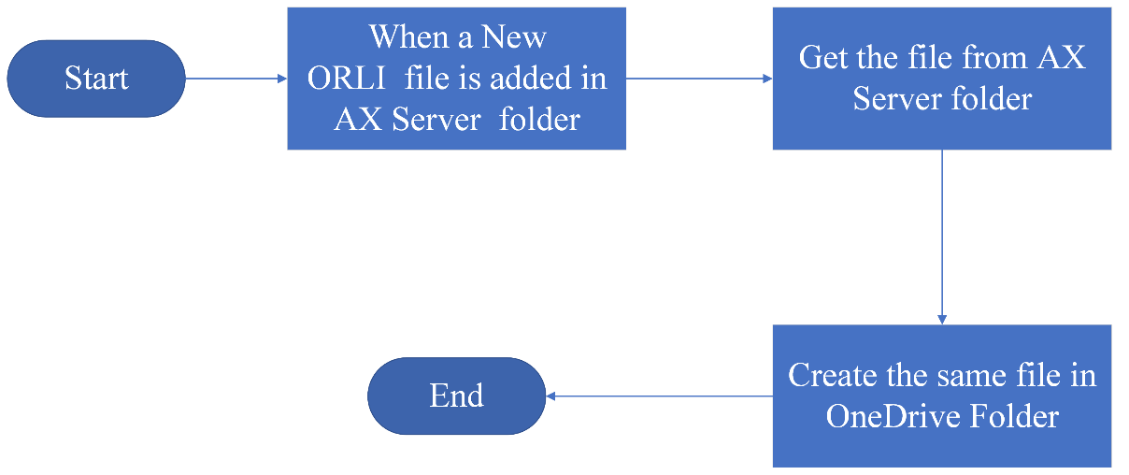**Flow Chart/ Algorithm: Copy ORLI file from AX Shared folder to OneDrive**

* Power Automate flow to copy ORLI file stored in AX shared folder path and store it into OneDrive. For which Power Automate flow requires a **“File System”** Premium connector.
* Power Automate flow to store ORLI file (*csv file) data into Dataverse in tabular format.
* In Dataverse there are 2 tables created for Header and Item invoice.
  + - Tables:

|  |  |  |
| --- | --- | --- |
| Table Name | Type | Details |
| Header_Invoice_FA Rework | Master Table | Table contains details of invoices |
| Items_Invoice_FA Rework | Data Table | Table contains all the items details of each invoice |

* Connecting Dataverse to Power App and make the required data visible.

**Dataverse mapping:**

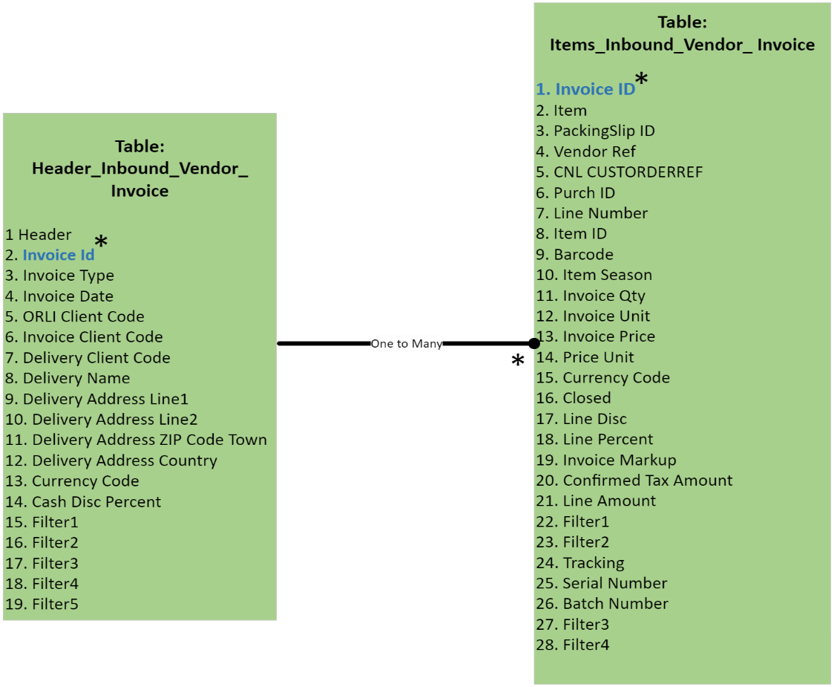

* Above ER represents ORLI file data mapping into Dataverse.
* In the above ER “Invoice Id” is the primary key with one-to-many relationship.

**Note:** Items_Invoice_FA Rework table does not have Invoice ID column in ORLI file. This column has created in Dataverse.

**ORLI File Data into Dataverse:**

* Header Invoice Table:

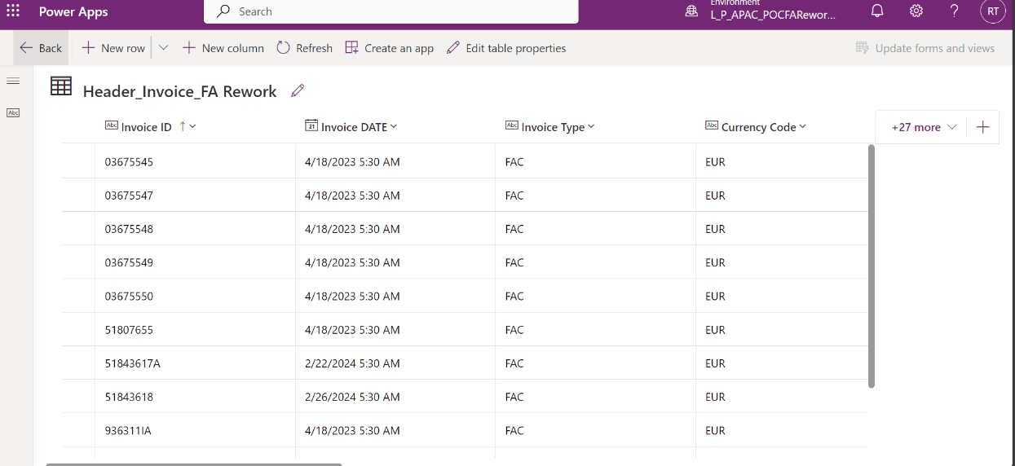

* 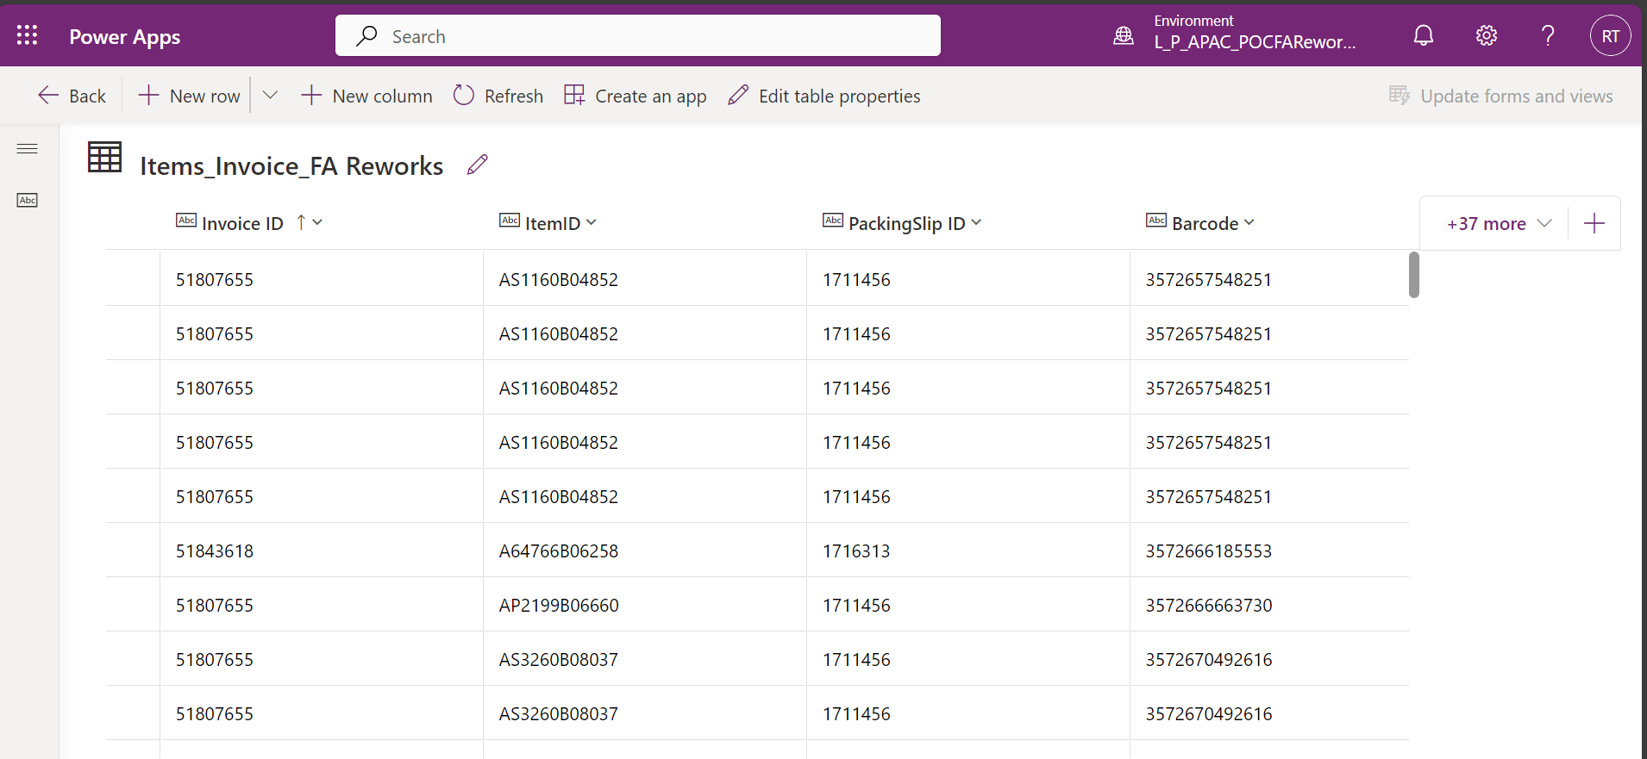Item Invoice Table:

**Power Automate flows used to execute step1 from fig:1.0:**

|  |  |
| --- | --- |
| Power Automate Flow | Connectors Used |
| Automated Flow to store ORLI file into OneDrive by taking it from AX shared folder. | 1. File System connector 2. OneDrive connector |
| Automated Flow to copy the file from OneDrive and store its Invoice data into Dataverse.  Dataverse Tables:   1. Header_Invoice_FA Rework 2. Items_Invoice_FA Rework | 1. OneDrive connector 2. Dataverse connector |

**Step2:** Since Shipment status, Invoice Status and pending invoice status is not available in ORLI file and hence we need to fetch these details directly from SQL server by executing SQL stored procedure.

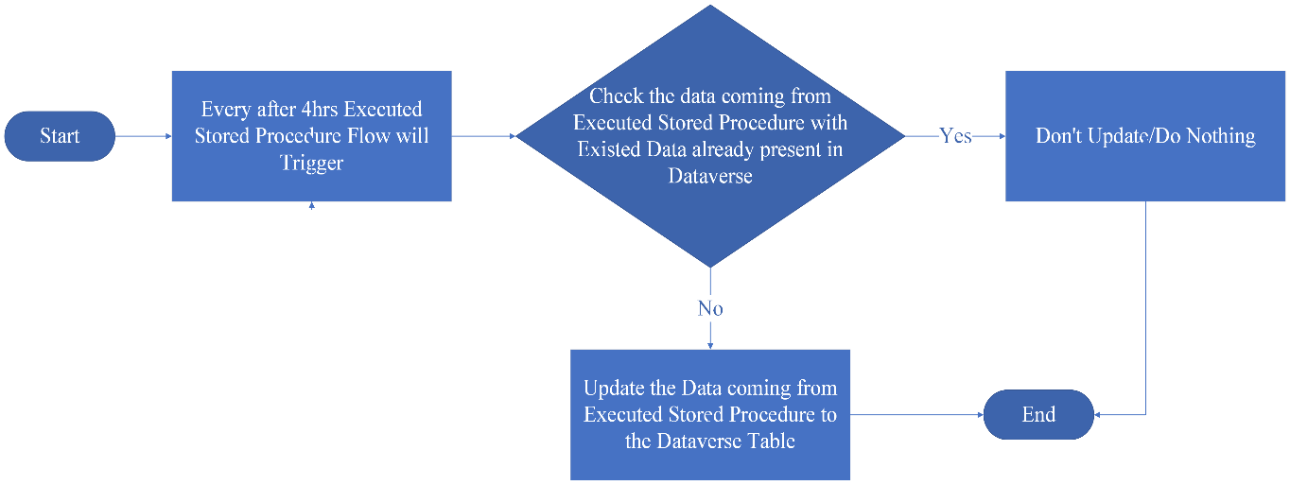**Flow Chart/ Algorithm: Executing Stored Procedure**

* Power Automate reoccurrence flow, to execute SQL stored procedure every interval of **4hours.**
* To execute SQL stored procedure, Power Automate flow requires a **“SQL premium connector”**.
* After executing store procedure, the data will be fetched from SQL server and will be stored into Dataverse.
* The flow triggers every after 4hrs and checks for if the data coming from SQL stored procedure is already present in Dataverse table or not.
* If data is not present, then add the respective fields into Dataverse and if data is already present and there is no change in the status of invoices then skip those invoice ids.
* In Dataverse the tables are created.

Tables:

|  |  |  |
| --- | --- | --- |
| Table Name | Type | Details |
| VendInvoiceShipmentStatus | Data Table | Table contains details of Shipment Status, Invoice and Pending Invoice Status. |
| Invoice-status-history | Data Table | Table contains details of Invoice Number/Shipment number that has pending invoice status. |

* Connecting Dataverse to Power App and make the required fields visible.

**Dataverse mapping: VendInvoiceShipmentStatus**

|  |  |  |  |
| --- | --- | --- | --- |
| Number | TypeOfData | Created On | Status |
| Shipment Number | Shipment | MM/DD/YYYY | Processed |
| Invoice Numbers | Invoice | MM/DD/YYYY | Processed |
| Invoice Numbers | Pending Invoice | MM/DD/YYYY | Processed |

* The above table represents the data in Dataverse for Invoice status and pending Invoice statuses coming from SQL after executing stored procedure.
* Number column represents – Invoice ID or Shipment Number.
* TypeOfData column represents – Status of the respective invoice as Shipment or Pending Invoice or Invoice.
* Date column represents – Date on which the record gets created in Dataverse.
* Status column represents – Status of TypeOfData as Processed.

**Note:** The stored procedure is designed to run exclusively on data that has been marked as "processed" and hence on executing stored procedure only “Processed” Invoice Number or Shipment Number will appear in Dataverse.

Although Power App application will also show “Not Processed” Invoice Number or Shipment Number When an invoice ID is missing in the latest data, the app interprets it as "Not Processed."

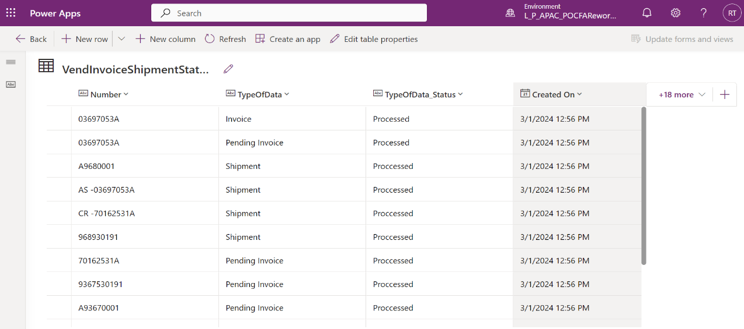**Shipment Status, Invoice Status and Pending Invoice Status Data into Dataverse:**

**Power Automate flows used to execute step2:**

|  |  |
| --- | --- |
| Power Automate Flow | Connectors Used |
| Automated Flow reoccurrence flow to trigger every interval of 4hrs to execute stored procedure and fetch the latest data into Dataverse without duplications. | 1. SQL connector 2. Dataverse connector |

**Application Interface Creation:**

Power App application to be created which will have similar interface as AX.

* 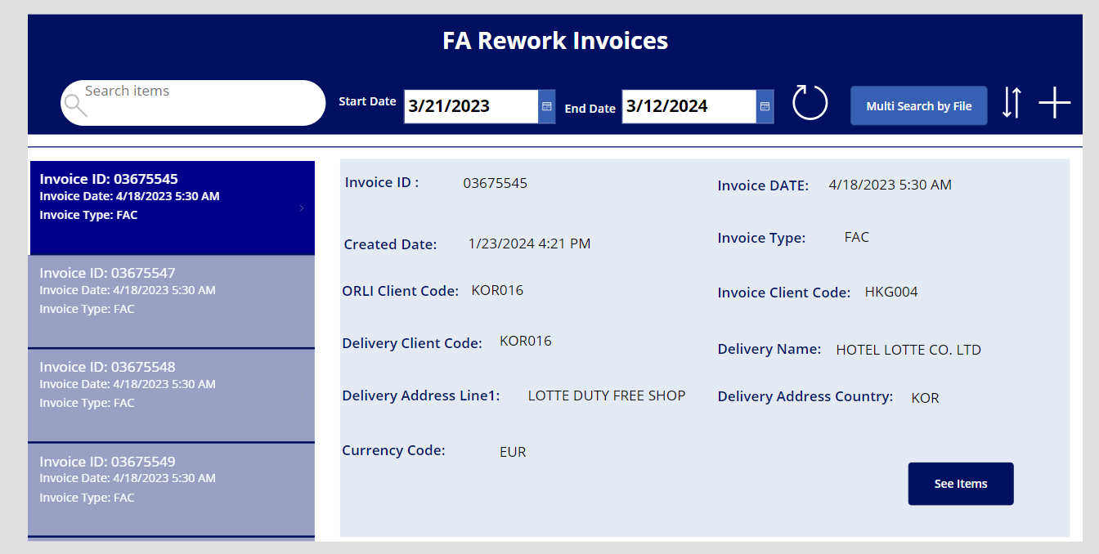Home Screen:

* Home Screen is a landing page in FA Rework application.
* The left menu show Invoice ID’s and the right side it gives the complete description of the selected invoice id.
* A search bar can work as single search or multi search at a time based on Invoice ID with coma (,) separated.
* Also, the data can be filtered by based on date range.
* “Multi search by file” button takes multiple Invoice id listed in excel file and search for all the invoice id’s at once.
* “See Item” button navigates user to item details of selected Invoice Id.

**Power Automate flows used in Home Screen:**

|  |  |
| --- | --- |
| Power Automate Flow | Connectors Used |
| A Power App trigger flow on click of “Multisearch by file” button to take the invoice ids listed in Excel file and populate them in search bar for multiselect. | 1. Excel connector |

* 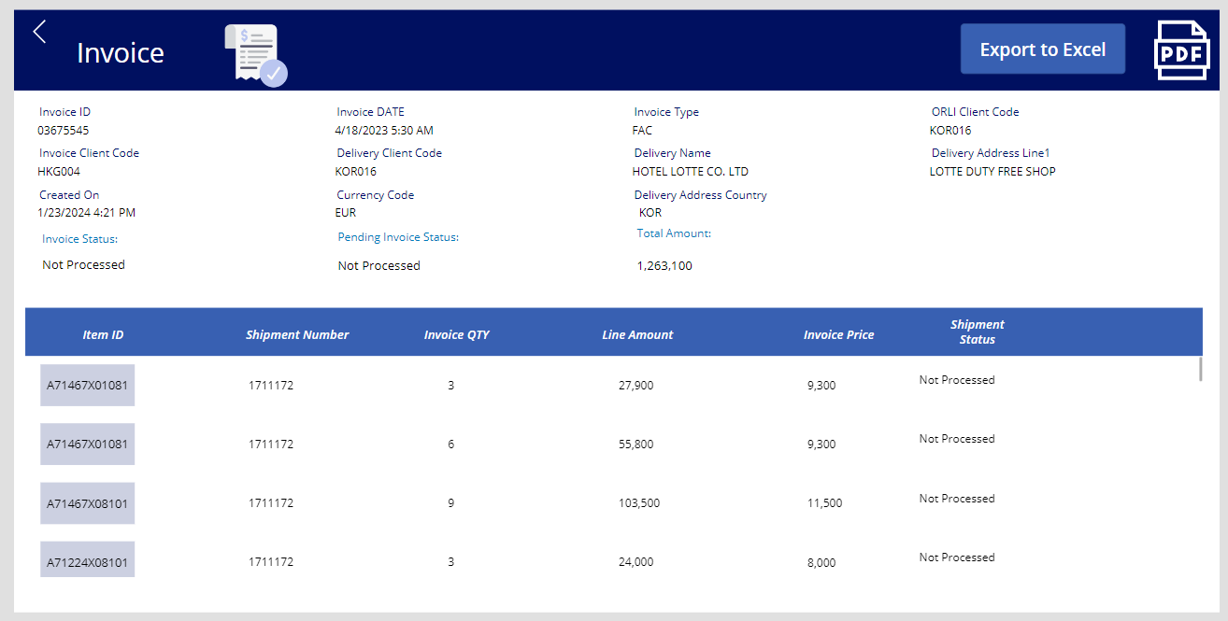Detail Screen:
* On click of “See Item” button the user navigates to Detail screen
* Having the details of invoice id and its item details.
* Export to excel button sends an Excel file with current screen data via mail to the User.
* On click on “PDF” icon sends data in a pdf format via mail to the User.

**Power Automate flows used in Detail Screen:**

|  |  |
| --- | --- |
| Power Automate Flow | Connectors Used |
| A Power Apps trigger flow, on click of Export to Excel” button which sends the excel file for selected data in outlook | 1. Excel connector 2. Outlook connector |
| A Power Apps trigger flow, on click of “PDF” icon populates selected data into Microsoft word template and converts the template into pdf and sends PDF via mail to user. | 1. Word Online (Business) Connector 2. Outlook connector |

* Header Screen:

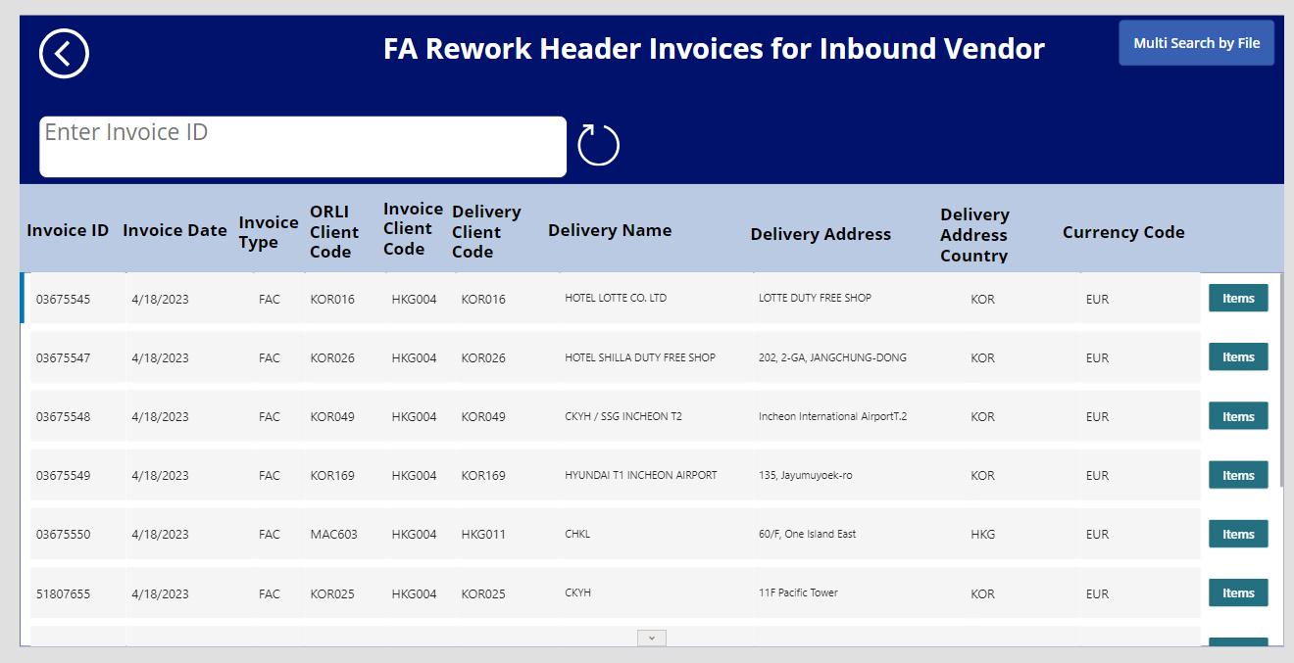

* An app interface separately for all headers in one screen.
* “Items” button navigates user to respective items.

# **Labels -NA**

|  |  |
| --- | --- |
| Label Id | Description |
|  | **Label id will be mentioned after checkIn** |
|  |  |

# **Roles and Security- NA**

# **Test Results**

1. **Generating Excel from Power App:** In the app on click of “Export to Excel” button the excel fill will be generated and send to logged in user via Outlook.

Refer the below excel file screen shot:

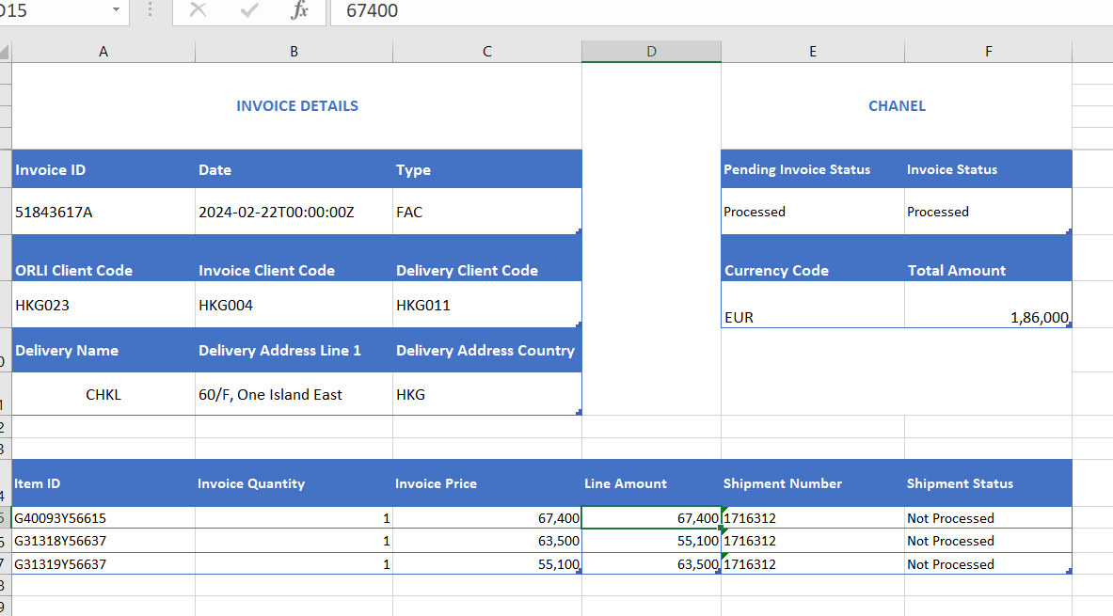

1. **Pdf Generation from Power App:** The Pdf will get generated and will be sent to logged in user via Outlook.

Refer the below image for pdf:

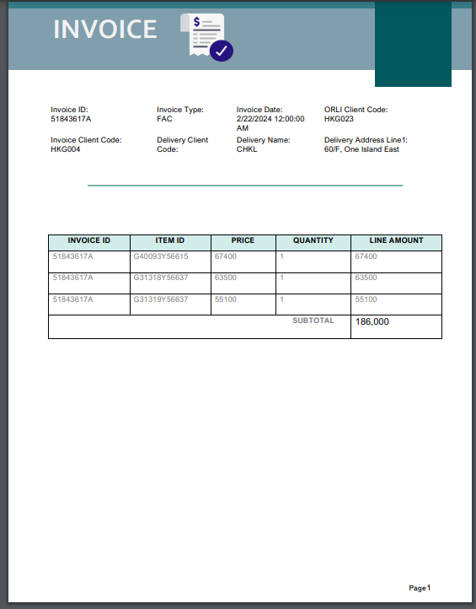

**Note:** Microsoft word template has been used for generating pdf.

Refer the attachment provided: [**FA Rework- PDF word Template.pdf**](https://capgemini-my.sharepoint.com/personal/almas_s-gajendragad_capgemini_com/Documents/Documents/FA%20Rework/FARework-Template.pdf)

# Required Features of the App:

|  |  |  |  |  |  |
| --- | --- | --- | --- | --- | --- |
| ***S. No*** | ***Open Points*** | ***Review Teams*** | ***Responsible*** | ***Status*** | ***Comment*** |
| 1 | Excel format not added here | TSA Team | RPA | Done | This feature is available in Power App. |
| 2 | Filter with Date of creation | TSA Team | RPA | Done | This feature is available in Power App. |
| 3 | 14days data should reflect by default | TSA Team | RPA | Done | This feature is available in Power App. |
| 4 | Pdf file header page, Page No. | TSA Team | RPA | Done | This feature is available in Power App. |
| 5 | Sending email / PDF from whom to whom and details? | TSA Team | AX | In Progress | Possible to do it in App |
| 6 | The pdf and on screen, could the number are shown with the thousand separator (","). | TSA Team | RPA | Done | This feature is available in Power App. |
| 7 | The PDF content "Shipment number" seems is starting 0000***, but seems the display is auto trim those leading zero. | TSA Team | RPA | Done | This feature is available in Power App. |
| 8 | User access to Power App tool | TSA Team | AX | Not implemented | User lists need to provide who will use this App in Prod |
| 9 | Need to understand the email sending logic to finance.eg. 1000 invoices received and processed in system; finance will receive 1000 emails (1 email 1 invoice)?? | TSA Team | AX | Not implemented | Business User to confirm on this feature |
| 10 | Application should have the multi search action where the user can search multiple invoice ids at a time | Business Team | RPA | Done | This feature is available in Power App. |
| 11 | Created Date should also be there in the app – Means the date of data getting added into the app. | Business Team | RPA | Done | This feature is available in Power App. |
| 12 | An interface needs to be added in app with separately for all headers in one screen. | Business Team | RPA | Done | This feature is available in Power App. |
| 13 | format of Invoice pdf needs a little change based on finance team’s requirements. | Business Team | RPA | Done | This feature is available in Power App. |
| 14 | There should be History of data of at least 2years. | Business Team | RPA | Done | The history of data will be available in Dataverse. It won't be deleted from Dataverse. |

# **CR#1 [Jira ID] [Description]-NA**

# **Business Requirements**

[Brief about the requirement without any technical explanation].

# **Assumptions**

1. [List out all assumptions]

# **Dependencies**

|  |  |
| --- | --- |
| **Dependency/ Impacts** | **Description** |
| [Reference process/ Jira] | [Details about the impact/dependency] |

# **Existing Behavior**

[Explain the current behavior of the solution/process. This is mandatory for bug fixes]

# **Desired Behavior**

## **Flow Chart/ Algorithm**

[Flow chart/ Algorithm about Logic]

## **Interface Field Mapping & Rules**

[Explain the interface specific information like Flow, Structure, Field Mapping and Rules]

## **Report Design and Field Mapping**

[Explain the report design, rules and field mapping for the fields in report]

## **Solution Details**

[Detailed explanation about technical changes including validation, design etc.]

# **Object List**

|  |  |  |
| --- | --- | --- |
| **Object Name** | **Object Type** | **Created/ Modified** |
|  |  |  |

# **Labels**

|  |  |
| --- | --- |
| Label Id | Description |
|  |  |
|  |  |

# **Roles and Security**

[Explain about the roles, duty and privilege and its permission to objects]

# **Test Results**

[Unit test cases and test results with screen shots. Include the scenarios from FS as mandatory cases]